`

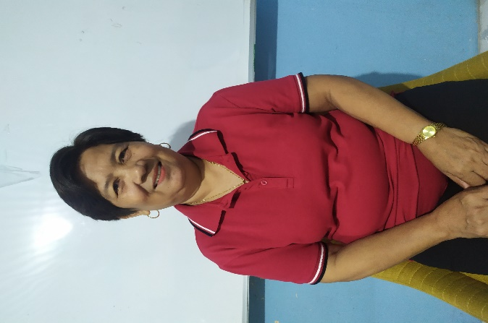

Brgy. CAPTAIN ALMA M. LAPNO Brgy. Councilor Gina P. Camerino Brgy. Councilor Helen S.Bacanto



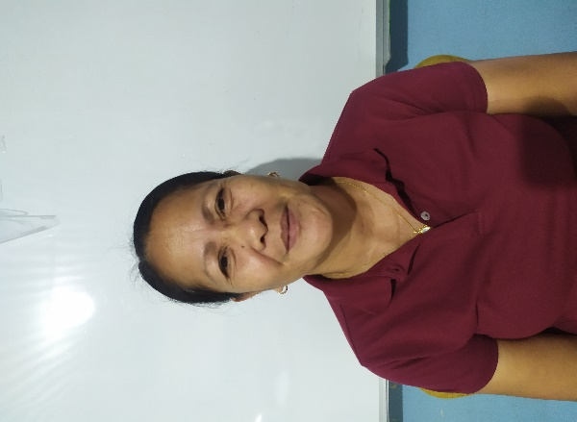

Brgy. Councilor James P. Rivera Brgy. Councilor Wilma B. Ilano

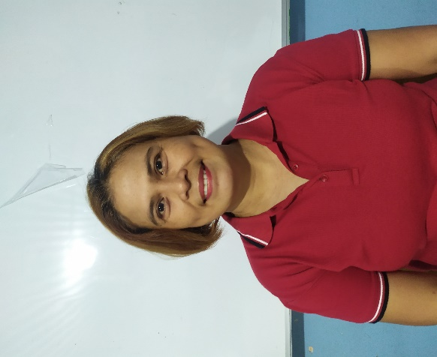

Brgy. Councilor Nomel A. Yagdulas Brgy. Councilor Mary Ann C. Beltran

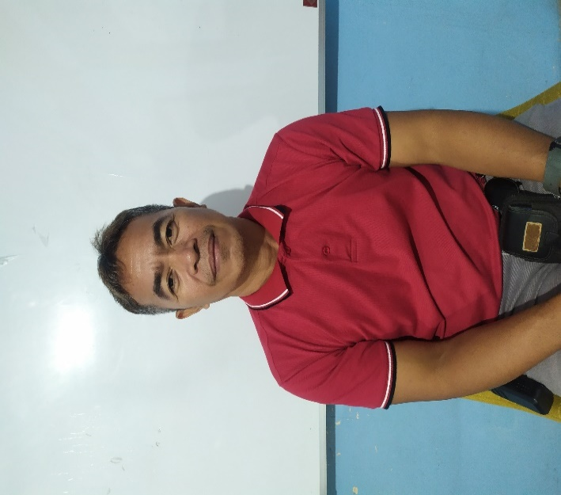

Brgy. Councilor Avelino Maglente, Jr.



Brgy. Secretary Mercy T. Dreza